H.T No
Regulations:
A20

Sreenidhi Institute of Science and Technology
(An Autonomous Institution)
Code No:8KC61 Date: 09-Aug-2024 (AN)

B.Tech III-Year II- Semester External Examination, August-2024 (Regular and Supplementary)

DESIGN OF STEEL STRUCTURES (CIVIL)
Time: 3 Hours Max.Marks:70

Note: a) No additional answer sheets will be provided.
b) All sub-parts of a question must be answered at one place only, otherwise it will not be valued.
c) Missing data can be assumed suitably.

Bloom's Cognitive Levels of Learning (BCLL)

Remember | L1 | Apply | L3 | Evaluate | L5
Understand | L2 | Analyze | L4 | Create | L6

Part - A Max.Marks:20
Answer all QUESTIONS

 |  | BCLL | CO(s) | Marks
1 | What is a steel structure | L1 | CO1 | [2M]
2 | Define a compression member | L2 | CO2 | [2M]
3 | Define a tension member | L1 | CO3 | [2M]
4 | Define joists | L2 | CO4 | [2M]
5 | Define plate girder | L2 | CO5 | [2M]
6 | Define purlin | L2 | CO6 | [2M]
7 | Define types of joints | L6 | CO1 | [2M]
8 | Applications of tension member | L3 | CO3 | [2M]
9 | Define Intermediate stiffners | L2 | CO4 | [2M]
10 | Applications of compression member | L3 | CO2 | [2M]
Part – B Max.Marks:50
ANSWER ANY FIVE QUESTIONS. EACH QUESTION CARRIES 10 MARKS.

 |  |  | BCLL | CO(s) | Marks
11. |  | Calculate the strength of a 20mm diameter bolt of grade 4.6 for the following cases . the main plates to be jointed are 12mm thick  - Lap joint  - Single cover butt joint with the cover plate of 10mm thick | L5 | CO1 | [10M]
12. |  | Calculate the value of least radius of gyration for the compound column of consisting of ISHB 250@536.6 N/m with one cover plate 300mmx20mm on each flange | L4 | CO2 | [10M]
13. |  | Determine the design tensile strength of130x12mm plate with M16 bolts as shown in fig  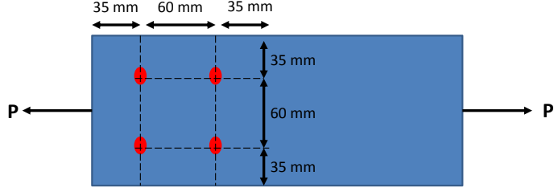 | L6 | CO3 | [10M]
14. |  | Design of laterally un supported beam for the following data effective span :4m , maximum bending moment 550knm, maximum shear force 200KN ,steel of grade Fe410,G=76.923X10^3N/mm^2 | L6 | CO4 | [10M]
15. |  | Define plate griders & elements of plate girder with a neat sketch | L3 | CO5 | [10M]
16. |  | Design a purlin for a roof truss having the following date: span of the truss=9.0m, spacing of truss=3m c/c, inclination of roof=30º, spacing of purlin=2m c/c, wind pressure=1.5KN/m², Roof coverage=A.C sheeting weighting 200N/m², Provide a channel section for purlin | L5 | CO6 | [10M]
17. | a) | Write the types of bolts | L3 | CO1 | [4M]
 | b) | Modes of failures of compression member | L5 | CO2 | [3M]
 | c) | Modes of failures of tension member | L6 | CO3 | [3M]
18. | a) | Write the classification of beams | L2 | CO4 | [4M]
 | b) | Write the difference between web splice and flange splice | L4 | CO5 | [3M]
 | c) | Write the component parts of truss | L6 | CO6 | [3M]
-- 00 -- 00 –

